# Class Diagram v1.0

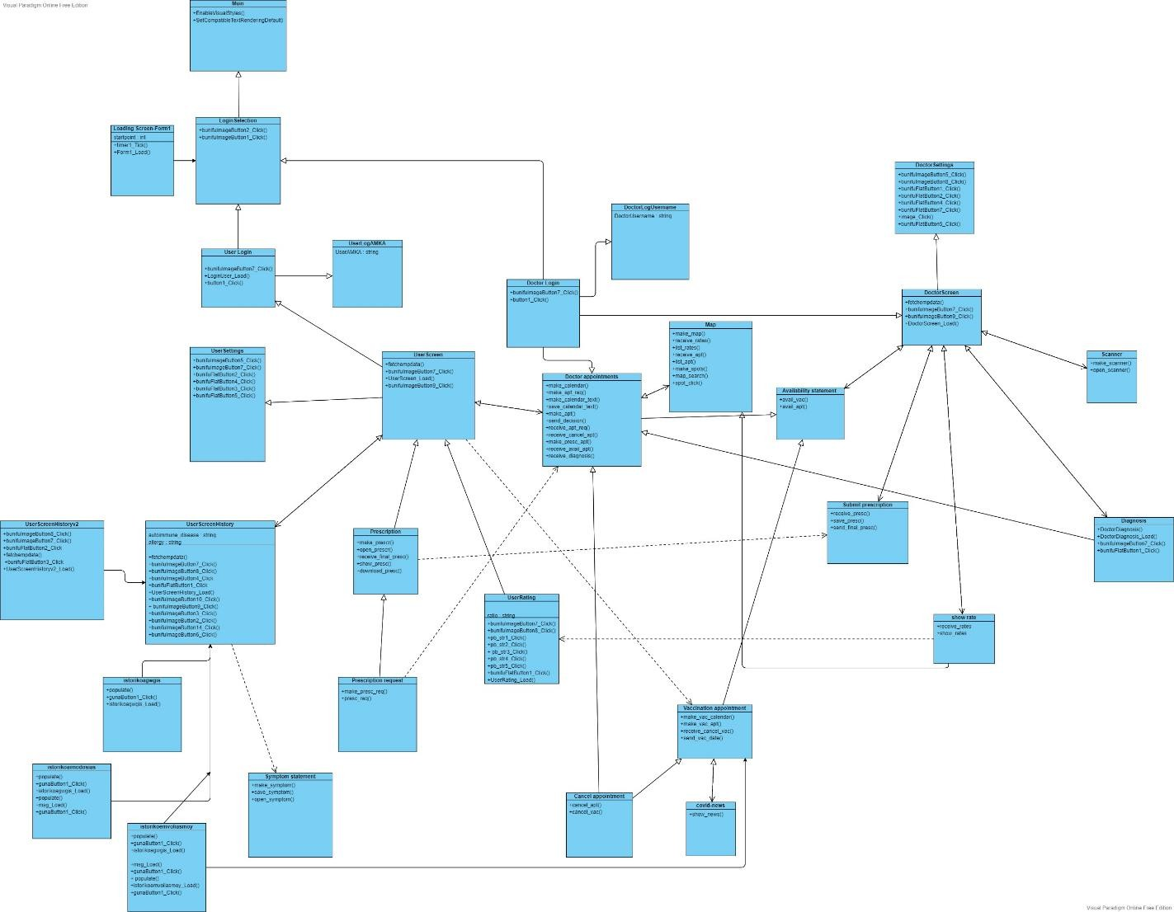

**Main : entity that contains the main of the application**

**LoadingScreen-Form1:**

**specially configured UI for loading at the beginning of the application before the login selection.**

**LoginSelection : Custom UI for user selection in the app.**

**UserLogAMKA : function for User login**

**UserLogin : function for User login**

**DoctorLogUsername : function for the Doctor's login**

**DoctorLogin : function for the Doctor's login**

**UserScreen : entity that contains all the basic information of the basic user and its various functions.**

**DoctorScreen : entity that includes all the basic information of the doctor and his various functions.**

**UserSettings : entity that contains all User settings**

**DoctorSettings :**

**entity that includes all Doctor settings**

**UserScreenHistory: function of the user, full list of the user showing their history.**

**UserScreenHistory2: function of the user, full list of the user showing additional items of their history.**

**Istorikoagwgis : user mode, full list of the user showing their treatment history.**

**Istorikoemvoliasmoy : user function, full list of the user showing vaccination history.**

**Symptom Statement : its operation**

**display history, enables the user to declare his symptoms.**

**Prescription : function of the user and the doctor that in one case displays a PDF document with the user's prescription while in the other case the doctor creates a PDF document for the user.**

**Prescription Request : function of the user who sends a request message for a prescription to a doctor**

**UserRating : Function of the user filling out a form to rate the doctor**

**Doctor Appointments : function of the user and the doctor's availability statement**

**which contains a Calendar with features for both users.**

**Map : entity that contains a specially configured map.**

**Vaccination Appointment : function of the user and the doctor that contains a Calendar with features for both users.**

**Cancel Appointment : user function for canceling the appointment with a doctor and for**

**vaccination.**

**Covid News : vaccination function to display a form with news.**

**Availability statement : doctor mode for declaration in the Availability Calendar and vaccination**

**Submit Prescription : doctor mode to fill out a form and create a PDF file.**

**Show rate: doctor mode to display user rating.**

**Diagnosis : doctor mode to fill out a diagnosis form.**

**Scanner: doctor mode with a built in scanner for scanning QR codes.**

**EXPLANATION OF METHODS**

**\* (methods where used more than 1 time, explained once and used many times)**

**fetchempdata() :**

**Method to pull the appropriate data from the database we have built.**

**bunifuFlatButton1_Click() :**

**Method to save all changes to settings.**

**bunifuFlatButton2_Click() :**

**Method to change address in settings.**

**bunifuFlatButton4_Click():**

**Method to change phone in settings.**

**bunifuFlatButton7_Click() :**

**Method to change password in settings.**

**bunifuFlatButton5_Click() :**

**Method to save the profile picture.**

**bunifuImageButton7_Click() :**

**Method for exiting our application.**

**bunifuImageButton9_Click() :**

**Method for entering the settings.**

**bunifuImageButton5_Click() :**

**Method for displaying the homescreen ( doctorScreen or userScreen ).**

**bunifuFlatButton3_Click() :**

**Method to change email in settings.**

**image_Click() :**

**Method that allows the user to browse and choose the profile picture they want to put.**

**UserScreen_Load() :**

**Method that uses fetchempdata() for User.**

**DoctorScreen_Load() :**

**Method using fetchempdata() for Doctor.**

**timer1_Tick() :**

**Method to place our timer on the progress bar.**

**Form1_Load(object sender, EventArgs e) :**

**Method to start the application.**

**button1_Click() :**

**Method for entering information to log in as Doctor or User**

**bunifuImageButton2_Click() :**

**Method for entering the application as a User.**

**bunifuImageButton1_Click() :**

**Method for entering the application as a Doctor.**

**bunifuFlatButton2_Click() :**

**Method to display the UserScreenHistory.**

**bunifuFlatButton1_Click() :**

**Method to display userScreenHistoryv2 .**

**UserScreenHistory_Load() :**

**Method to call fetchempdata().**

**bunifuImageButton10_Click() :**

**Method for displaying blood donation history.**

**bunifuImageButton9_Click() :**

**Method for showing vaccination history.**

**bunifuImageButton3_Click() :**

**Method for showing allergies**

**bunifuImageButton2_Click() :**

**Method for the occurrence of autoimmune diseases**

**bunifuImageButton14_Click() :**

**Method for showing old treatment.**

**bunifuImageButton6_Click() :**

**Method for displaying current treatment.**

**UserScreenHistoryv2_Load() :**

**Method to call fetchempdata().**

**populate() :**

**Method to pull the appropriate elements from our base and use them to give elements to our classes and methods.**

**istorikoagwgis_Load() :**

**Method that calls populate().**

**gunaButton1_Click() :**

**Method for creating a button that does hide.**

**istorikoemvoliasmoy_Load() :**

**Method that calls populate().**

**make_symptom() :**

**Method that creates a symptom submission form.**

**open_symptom() :**

**Method that opens the symptom submission form.**

**save_symptom() :**

**Method for storing symptoms.**

**make_prescr() :**

**Method for creating a prescription submission form.**

**open_prescr() :**

Method for opening and completing the prescription form.

receive_final_presc() :

Method for receiving ready-to-process prescriptions.

show_presc() :

A method that enables the opening of final prescriptions.

download_presc() :

Method for locally downloading the prescriptions in pdf.

make_presc_req() :

Method for creating a submission form for a prescription request.

presc_req() :

Method for sending the prescription request to a doctor.

make_calendar() :

Method for creating a Calendar with the possibility of entering text into the dates.

## make_apt_req() :

Μέθοδος για την δημιουργία φόρμας υποβολής User για την αίτηση ραντεβού με γιατρό.

## make_calendar_text() :

Μέθοδος για την δημιουργία κειμένου στις ημερομηνίες του Calendar.

**save_calendar_text() :**

**Method to store text in dates.**

**make_apt() :**

**Method that allows you to accept or reject the appointment request.**

**send_decision() :**

**Method for sending a message with the appointment decision (accept or reject).**

**receive_apt_req() :**

**Method for the doctor to receive appointment requests.**

**receive_cancel_apt() :**

**Method for the doctor to receive appointment cancellations.**

**make_presc_apt() :**

**Method for opening the prescription window.**

**receive_avail_apt() :**

**Method for obtaining availability of doctors.**

**receive_diagnosis() :**

**Method for obtaining the diagnosis.**

**UserRating_Load() :**

**Method for connecting the ratings from our database to the base**

## pb_str1_Click() :

## 1 star rating method.

## pb_str2_Click() :

## 2 star rating method.

## pb_str3_Click() :

## 3 star rating method.

## pb_str4_Click() :

## 4 star rating method.

## pb_str5_Click() :

## 5 star rating method.

## bunifuFlatButton1_Click() :

## Method for performing grading.

## make_map() :

## Method for creating a map based on the user's current location.

**receive_rates() :**

**Method for obtaining doctors' rates.**

**list_rates() :**

**Method for entering the rates in the correct places on the map.**

**receive_apt() :**

**Method for receiving users' appointments with doctors.**

**list_apt() :**

**Method for entering appointments in the appropriate places on the map.**

**make_spots() :**

**Method for creating points of interest on the map (hospitals, doctors).**

**map_search() :**

**Method to search the map.**

**spot_click() :**

**A method that allows you to choose a hospital or doctor and displays evaluations and appointments.**

**make_vac_calendar() :**

**Method for creating a Calendar with the possibility of entering text in the dates.**

**make_vac_apt() :**

**A method that allows you to select a vaccination date in the Calendar.**

**receive_cancel_vac() :**

**Method to get vaccination cancellation by updating Calendar.**

**receive_avail_vac :**

**Method to get doctor availability.**

**send_vac_date():**

**Method for sending the date of the User's vaccination to his Calendar.**

**cancel_apt() :**

**Method for sending appointment cancellation.**

**cancel_vac() :**

**Method for sending vaccination cancellation.**

**show_news() :**

**Method for displaying news at the appropriate point in the application.**

**avail_apt() :**

**Method to update the Calendar for the doctor's availabilities.**

**avail.vac() :**

**Method for updating the Calendar for vaccination availabilities.**

**receive_presc() :**

**Method for receiving the user's prescriptions.**

**save_prescr() :**

**Method to save prescription form to pdf.**

**send_final_presc() :**

**Method for sending ready prescriptions.**

**receive_rate() :**

**Method for obtaining doctor's ratings.**

**show_rates() :**

**Method for displaying ratings at an appropriate point.**

**DoctorDiagnosis()**

**Method for connecting to our database**

## bunifuFlatButton1_Click()

## Method for creating or updating the diagnosis.

## bunifuImageButton7_Click()

## Method to exit diagnosis.

## make_scanner() :

## Method for creating a QR code scanner.

## open_scanner() :

## Method for entering the scanner.